Content 6

**Conditional Expressions**

Sometimes we want to play pubg on our phone if the day is Sunday.

Sometimes we order Ice-cream online if the day is sunny.

Sometimes we go hiking if our parents allow.

All these are decisions that depend on the condition being met.

In python programming too, we must be able to execute instructions on a condition(s) being met. This is what conditions are for!

##### **If else and elif in Python**

If else and elif statements are a multiway decision taken by our program due to certain conditions in our code.

**Syntax:**

'''

if (condition1): // if condition 1 is true

print(“yes”)

elif (condition2): // if condition 2 is true

print(“No”)

else: // otherwise

print(“May be”)

'''

**Code example:**

a = 22

if (a>9):

print(“Greater”)

else:

print(“lesser”)

**Quick Quiz:**Write a program to print yes when the age entered by the user is greater than or equal to 18.

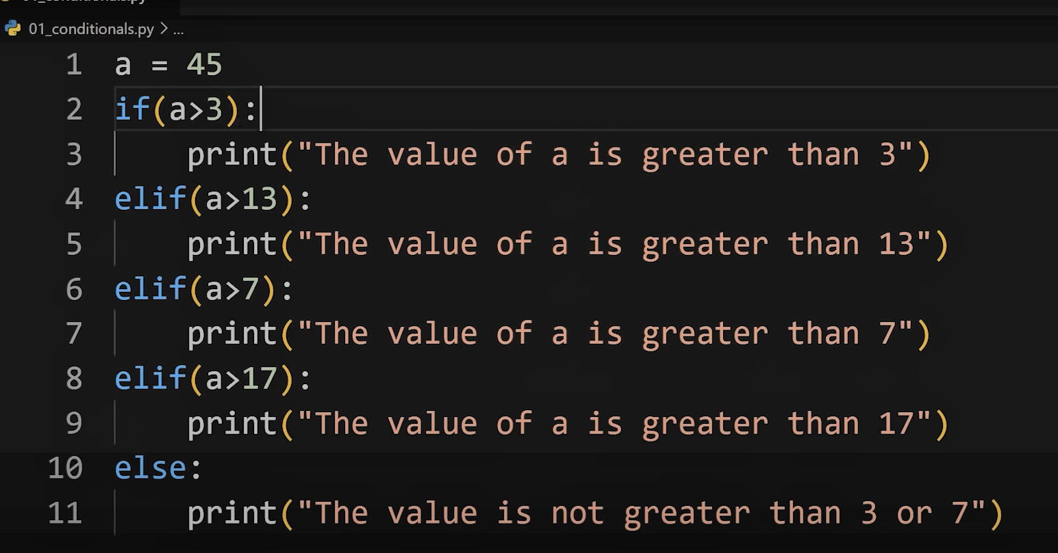

##### **Relational Operators**

Relational operators are used to evaluate conditions inside if statements. Some examples of relational operators are:

= = -> equals

>=  -> greater than/equal to

<=, etc.

# Finding the greatest numbe inputed by user

num1 = int(input("Enter N1: "))

num2 = int(input("Enter N1: "))

num3 = int(input("Enter N1: "))

num4 = int(input("Enter N1: "))

if(num1 > num4):

    f1 = num1

else:

    f1 = num4

if(num2 > num3):

    f2 = num2

else:

    f2 = num3

if(f1 > f2):

    print((str(f1) + " is Greatest....."))

else:

    print((str(f2) + " is Greatest...."))

**Output:**

Enter N1: 2

Enter N1: 4

Enter N1: 8

Enter N1: 9

9 is Greatest.....

##### **Logical Operators**

In python, logical operators operate on conditional statements. Example:

and -> true if both operands are true else false

or -> true if at least one operand is true else false

not -> inverts true to false and false to true

##### **elif clause**

elif in python means [else if]. if statement can be chained together with a lot of these elif statements followed by an else statement.

'''

if (condition1):

#code

elif (condition 2):

#code

elif (condition 2):

#code

….

else:

#code '''

* Above ladder will stop once a condition in an if or elif is met.

**Important Notes:**

* There can be any number of elif statements.
* Last else is executed only if all the conditions inside elifs fail.

# for logical operaotor

n1= 5

if(n1>2 and n1<7):

    print("n1 is greater than 2 and smaller than 7....")

if(n1>4 or n1>6):

    print("n1 is grater than 4 and also Greater than 6...")

if( n1 is not 2 ):

    print("n1 is not equal 2 ")

**Output:**

n1 is greater than 2 and smaller than 7....

n1 is grater than 4 and also Greater than 6...

n1 is not equal 2